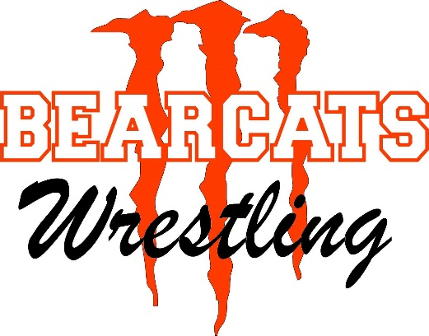
MONROE SUMMER YARD BRAWL
TEST YOUR ABILITY NEXT TO THE FACILITY
TUESDAY JULY 12-THURSDAY JULY 14, 2016
Monroe High School Wrestling is hosting a Team Dual Camp at the Bearcat Wrestling Athletic Center (Sky Valley Ed. Center) located on Hill Street in Monroe, WA on the above dates. Our goal is to have 14-18 teams of any classification to come and participate in 3 days of nothing but live wrestling and get in 15-18 real matches! We just want to gain experience and have some fun while we do it!!
- Only $300 per team (incoming Frosh-Senior). Bring as many as you can, extras will be placed on other teams to fill holes. We’ll make an All Star team if we have enough extras!
- Individual wrestlers are $75 and will be placed on a team with an opening.
- Male and Female locker rooms with showers available.
- We will weigh in on the first day, honor system from then on.
- Minimum of 15 matches with three 1:30 rounds. Wrestling starts at 9 daily.
- There will be a concession stand open all day, you are welcome to bring a cooler.
- Located 3 blocks from Restaurants, Movie Theaters, Grocery Stores
- Camping available at the Evergreen State Fairgrounds 360-805-6727. We also have several coaches with camping space on their property that is available free of charge on a first come, first serve basis. Contact Mark Dalbeck for details.
- Wednesday evening Lake Roesiger Romp with swimming, BBQ, and outdoor movie.
- Contact Information: Mark Dalbeck 360-421-4629 Mdalbeck@hotmail.com

