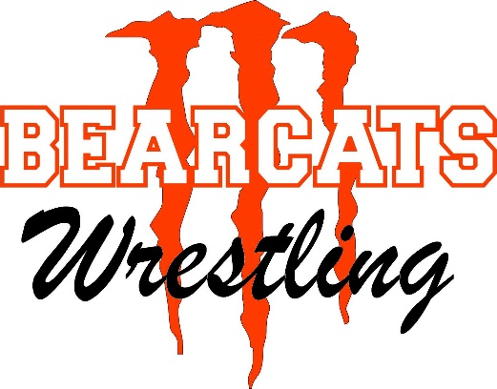
MEDICAL RELEASE FORM
I hereby authorize my child’s participation in the Monroe Summer Yard Brawl Duals. I know of no physical, mental, emotional, or behavioral problems that may affect my child’s ability to safely participate. The camp’s coaches are authorized to attend to any health problem or injury regarding my child that may occur at camp, practices, matches, or technique sessions. I understand that there is a risk of injury when participating in the sport of wrestling. Neither I nor my family, nor my child will hold Monroe Wrestling, Monroe School District, camp directors, or coaches liable for injuries/illness or expenses relating to injury/illness sustained while my child is participating at the camp or team duals.

___________________________________________________________________
Participant’s Name High School

___________________________________________________________________
Signature of Parent/Guardian

Please list any health issues, injuries, or allergies that pertain to your athlete below.
____________________________________________________________________________________________________________________________________________________________________________________________________________________________________________________________________________________________________________________

